Apocalypse Card Preview: Flagbearers
Gary Wise
In examining Apocalypse, one can't help but notice how creative R&D got with some of the new creature abilities. In addition to the good, old fashioned, abilities like trample and flying that cross over the color-based political boundaries of the game, the set designers have created a new, unique creature ability specific to each color which suits the template for that color to a tee. The Flagbearers epitomize this notion.
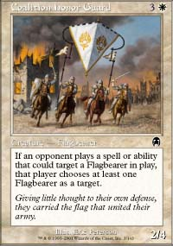
A new creature type, the Flagbearer is a human magnet. Any time your opponent casts a spell that could target a Flagbearer in play, they must choose a Flagbearer as one of the targets. While this may not seem like that big a deal at first, it can lead to some very difficult situations for your opponent, especially where their own creature enhancing spells are concerned.
Magic is a game of decisions. From the decision to mulligan to the decision to make that final, sweeping attack, each player must make a series of choices that will eventually, right or wrong, decide the course of any given game. The Flagbearer creature type takes the opportunity to make correct decisions out of your opponent's hands. This means that as long as its in play, your correct choices will win your games.
The moment you cast the 1/1 Standard Bearer or, more optimally, the 2/4 Coalition Honor Guard, you can cross a number of seriously detrimental spells off your mental checklist. Your opponent attacks with a 2/2 and you have a 3/3? No problem, just block, their Explosive Growth will target your Flagbearer. Your deck is a little slow and you're facing a deck full of Sinister Strengths and Maniacal Rages? No problem, just cast the Standard Bearer turn two.
Purely aggressive decks often rely on such creature enhancement in order to deal twenty points of damage as quickly as possible, meaning the Flagbearer ability is optimal against them, but that doesn't limit them to use against just aggressive decks. There are a lot of often-used creature abilities out there that we take for granted, but the controllers of those abilities will quickly start finding themselves becoming frustrated with the presence of the Flagbearers. "Inside the attack step, I'll tap your flyer." No, you won't.
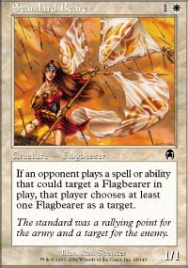
It's pretty simple: the main purpose of the Bearers is to disrupt the flow of your opponent's deck. Yes, there are spells out there that will function despite the Flagbearers being in play (Rushing River and other dual target spells come to mind) but even then, spells like Magma Burst are a lot less exciting when, if kicked, they must target the Coalition Honor Guard and its four-power hide.
Examples like this one show just how effectively the Flagbearers protect your other creatures. Often, your high-powered creatures find themselves being targeted by kill spells as soon as they enter play, but with a Flagbearer in play, you needn't worry about such eventualities. With the Honor Guard in play, you can freely cast your Tsabo's Assassin, Dragon or like-powered creature, secure in the knowledge that your opponent's spells won't be able to target them until it's too late.
As solid as the Flagbearer ability is, you'll find it becoming more powerful in conjunction with other cards. If, for example, your Flagbearer finds itself in play with Tidal Visionary, Blind Seer or other cards capable of changing the Bearer's color, a number of spells like Agonizing Demise will be nullified. Additionally, color specific spells that could otherwise bypass the Bearers, like Slay, will leave you with options as to how to proceed. Furthermore, with so few spells actually capable of removing the Honor Guard, if you can find a way to protect it, Confound for example, then your opponent's deck should be thrown off its course long enough for you to ride to victory.
You shouldn't see the Flagbearers in Constructed because, frankly, they just aren't efficient enough for their cost and mass kill is abundant, but they should prove an important influence in Limited play, where most decks rely on a third of their spells and their targeted effects. The Honor Guard is definitely a solid pick, while the Standard Bearer will show itself in the least to be a strong sideboard card. Everyone is going to make a few mistakes because of these guys. Hopefully, you'll be the beneficiary.

